STATEMENT OF RESPONSE AND UPDATED DRAFT WATER RESOURCE MANAGEMENT PLAN

October 2018

Albion Water Limited
www.albionwater.co.uk

Contents
1 Statement of Response 3
2 Summary 7
3 Background 8
3.1 Albion Water’s Plan - Structure and Comments 8
3.2 Water Legislation 8
3.3 Albion Water’s Inset Appointments 9
3.4 Pre – Consultation 11
4 Water Resources 12
4.1 Upper Rissington 12
4.2 Five Oaks 13
4.3 Outage 14
4.4 Severe droughts 14
4.5 Impact of climate change 14
5 Water Demand 15
5.1 Historic levels of demand 15
5.2 Base Year 16
5.3 Leakage 17
5.4 Demand forecasting 19
6 Headroom 21
7 Supply demand balance 21
8 Sensitivity 23
9 Drought reliability and drought actions 23
9.1 Upper Rissington 23
9.2 Five Oaks 24
9.3 Green Water 24
10 Other matters referred to in Guidance and Directions 25
10.1 Greenhouse gas emissions accounting 25
10.2 Resilience 25
10.3 Commercial confidentiality 26
10.4 Board assurance 26
10.5 Tables 26
10.6 Table changes from Draft Plan 27

Statement of Response
Albion Water only received one set of comments on its Draft Water Resources Management Plan. This was from the Environment Agency and was received directly from them. No others were forwarded to us from Defra.
The Environment Agency made a series of recommendations and areas for improvement. These are reproduced below along with a response to each of them and what changes we have made (not planning to make) to the plan. This document also includes (Section 2 onwards) an Updated Draft Water Resources Management Plan with these changes incorporated.
Recommendation 1 – Ensure there will be no deficits in the Five Oaks inset area if non-potable water supply from recycling plants is not available

Both existing resource zones in the plan will be supplied with both potable and non-potable ‘green water’ from onsite water recycling plants. The company has not included an appropriate assessment of outage from these water recycling plants in the plan. Including both outage of the recycling plants and an allowance for headroom will cause Five Oaks to go into deficit in a dry year, presenting a potential risk to the security of supplies. If non-potable water is not available from the recycling plant then the company may not have sufficient supplies to meet the demands of its customers.

It is also unclear if outage data from the recycling plants will be recorded. Without collecting this information the company will not be able to accurately calculate outage in the future.

We recommend the company:
• assesses outage from its water recycling plants and includes values for outage allowance in the planning tables
• provides a plan or states how it will collect outage data in the future
• further considers and describes how it will maintain its supplies where water from its non-potable water recycling plant is not available due to an outage event. For example, the company could provide assurance that a legal agreement is in place with Essex and Suffolk Water to ensure they can provide additional water as part of the bulk supply in an emergency

Response – the plan (Outage section) has been updated to give more detail of how any short term non-availability of the plant during a dry year will be managed. The plan now describes how output / outage data from the green water plants will be recorded and analysed.
Direction 3(b) Describe the annual average risk of all restrictions as a percentage, and how they change through the planning period

The company has not stated the average annual risk that it may need to impose for temporary water use restrictions, ordinary drought orders and emergency drought orders as a percentage, for Upper Rissington, as required by Direction 3(b). The company has presented sufficient information for its Five Oaks supply area.

For Upper Rissington the company must provide its estimate of the planned annual risk for temporary water use restrictions, ordinary drought orders, and emergency drought orders as a percentage to meet Direction 3(b). If the WRMP reflects the level of service of the incumbent water company, it must still state its level of service in its own WRMP to comply with Direction 3(b).
Response – updated wording has been obtained from Thames Water and included in the updated plan. Thames Water (whose wording it is) confirm that it meets the requirements of Direction 3(b).
Direction 3(e)(i) Describe the assumptions made regarding the implications of climate change, including in relation to the impact on each of its supply and demand measures
The company has not provided an estimate or described the assumptions it has made regarding the impacts of climate change on its future demand forecasts. This is required by Direction 3(e)(i).
The company must include an assessment of the impacts of climate change on its demand measures in the final planning scenario to meet Direction 3(e)(i).
Response – an assessment has now been included in the plan
Direction 3(h) Describe its assessment of the cost-effectiveness of domestic metering types

The company has not provided an individual assessment of the cost-effectiveness for each type of household metering, including compulsory, selective, change of occupier and optant, in the Upper Rissington area as required by Direction 3(h).

The company must provide an assessment of the cost-effectiveness of each of the above type of metering, in the Upper Rissington area, to meet Direction 3(h). This should be presented individually to allow a comparison of each metering type.
Response – The Plan has been updated to give an assessment of cost effectiveness of each type of metering where this is possible in the context of two small NAVs.

Direction 3(j) Explain why it is forecasting a rise in leakage in the planning period
The water resources planning tables show an unexplained rise in leakage in the Upper Rissington resource zone in 2020/21 and 2021/22. The plan therefore does not sufficiently comply with Direction 3(j).
We recommend the company either amends its leakage estimate in the planning tables to show no unexplained increases in leakage, or provides an explanation of why leakage increases between 2020/21-2021/22 in order to meet Direction 3(j).
Response – there was an error in the tables which has been corrected. Leakage does rise slightly, particularly at Five Oaks but this is due to the sites being build out and serving more customers.
Improvement 1 – Assess non-drought resilience

The company has not provided any information to demonstrate that its plan is resilient to non-drought hazards. We recognise the company derives all its supplies from bulk supply contracts but its network may still be vulnerable to hazards such as freeze-thaw incidents. We suggest the company consider whether any non-drought risks could affect its water supply resilience and provide further information on this in its final plan.
Response – an assessment of non drought resilience has now been provided, in particular relating to an interruption to a bulk supply and a leakage breakout driven by cold weather – e.g. the Beast from the East.
Improvement 2 – Confirm the security of supplies for its current and future supply areas

The company does not state the expected duration of the bulk supply agreement in place to supply both resource zones. The company should ensure that the plan includes sufficient details of the duration of the bulk supply agreements to provide assurance supplies are secured for the full planning period. We suggest that the company should work with the relevant incumbent water company to ensure the bulk supply volumes presented in its plan are consistent with those set out in the incumbent’s plan.
Response – the plan has been updated and now confirms that there is no termination date on the agreement and therefore they will be in force for the period of the plan.
Improvement 3 – Improve leakage estimates

The plan states that, due to a lack of usable data, leakage for both resource zones has been assumed to be 4%. It is unclear how the company has derived estimates for total leakage values in the planning tables or if those values are correct, as data in the water resources management planning tables does not appear to show leakage as 4% of distribution input. We suggest the company should continue to collect data to demonstrate that it understands its leakage and can provide an accurate leakage forecast across the planning period. Linked to Direction 3(j), it should also set out a plan to show that it will not let leakage rise and adhere to government aspirations.

The plan also does not state whether the company intends to use the Consistency of Reporting Performance Measures (UKWIR 2017) method to assess its current leakage and to inform its future leakage forecasts.
We suggest the company:
clearly explains how the leakage estimates in the planning tables have been derived, how they relate to the 4% assumption and amends the planning tables to ensure that leakage is correct and consistently presented throughout its plan
• clearly shows what options have been considered to maintain low levels of leakage
• states if it intends to use Consistency of Reporting Performance Measures (UKWIR 2017) methodology in the future, identify when data will be available and shows what steps it is taking to comply with the new approach; alternatively it should explain why it will not be using the revised methodology

Response – an error in the table for leakage at Upper Rissington has been corrected. No change has been made to the 4% assumption. Nightlines indicate leakage is almost zero at Upper Rissington, the 4% assumption allows for the uncertainty in this estimate and is consistent with the demand / financial models we submitted to Ofwat when we obtained the NAVs. Given this low level of leakage and the simplicity of our systems we have no plans to use the UKWIR methodology at present.

Improvement 4 – Include and provide sufficient details for all new areas the company may supply

We are not aware of any new Albion Water applications for inset areas since Five Oaks inset area was licensed in 2016. However, the company does not explicitly state whether it will be looking to increase the number of resource zones (inset areas) served. It does not set out sufficient information to describe how it will incorporate any new resource zones in its plan. This means there is a risk that new resource zones may not be accounted for in the plan.

We suggest the company:
• includes a statement in the plan stating whether it intends to apply for new resource zones (inset areas) following final plan publication
• sets out the process it will follow to update its WRMP when a new appointment is granted; for example, reporting in the annual review process and updating and appending the information to the published WRMP

Response – we have updated the plan to state that we are pursuing new NAV opportunities, that we will share the supply / demand elements of our NAV applications with the EA (the bulk suppliers will be aware via the contract negotiations) and incorporate the new areas within our WRMPs at the next cycle.

Summary
The Water Industry Act 1991 (as amended by the Water Act 2003) underlines the importance of a water company’s ability to meet the supply and demand requirements of their customers both currently and into the future. This document and associated tables outline Albion Water’s supply demand balance through to 2045 and is produced as required by the Water Act 2003, which established a statutory duty for a water company to produce a Water Resources Management Plan (WRMP). Albion Water has taken into consideration relevant Directions and guidance documentation in compiling this Plan.
To date Albion Water Limited has been granted two inset appointments under Ofwat’s new appointments and variations (NAV) process where it is responsible for the supply of drinking water. These are:
- Upper Rissington, Gloucestershire
- Five Oaks, Essex
Water efficiency is at the heart of both of these developments and Albion Water’s overall approach to water and sewerage services. Unlike most NAVs we don’t just import the water in bulk to the development and resell it after the “last mile” of the distribution system – instead we seek to add value to the developer, customer and the environment by recycling water from our on-site sewage treatment works for non-potable purposes – particularly toilet flushing and garden use. This reduces the demand on the potable system by approximately 30%, reducing per capita consumption (PCC) to about 85 litres per person per day.
As well as providing customers with a non-potable supply we ensure water efficiency by keeping a very tight control on leakage. When we took on the Upper Rissington development leakage was completely out of control. The amount of water supplied by the incumbent was up to five times what it currently is, but only supplied a third of the houses that we now supply.
Similarly on the waste water side of our business we don’t just collect sewage from the “first mile” of the waste water network before discharging the untreated effluent into the incumbents network. Instead we provide local sewage works which treat the effluent to a high standard and return the water to the environment close to where it was used.
This plan demonstrates that the combination of the bulk supplies and water recycling plants provide enough water to meet our customers demand for water over the next 25 years. At Five Oaks we need to clarify with Essex and Suffolk Water whether the flexibility in maximum volume that is written into the bulk supply contract would be sufficient to cover unexpectedly high demands or a major outage at the water recycling plant.
The bulk supply agreements require us to match the incumbents’ restrictions policy. However, where water is supplied from recycled water we don’t expect to impose restrictions unless a drought has a return period of 1 in 200 years or worse.

Background

Albion Water’s Plan - Structure and Comments
The Water Act 2003 places a statutory duty on all water companies to prepare and maintain a WRMP under section 37A to 37D of the Water Industry Act 1991. Albion Water has adopted the guidelines developed by the Environment Agency to ensure that all essential aspects of its statutory duty are covered in this draft WRMP submission.
All water companies operating within England and Wales must produce a WRMP every 5 years or when there is a material change of circumstances or the Secretary of State or Welsh Minister direct that a new plan be prepared. The WRMP identifies how Albion Water intends to provide a sustainable, efficient, secure and affordable supply of water to its customers. This plan identifies how Albion Water intends to maintain the balance between supply and demand over the next 25 years.
This document has been checked for information that may be sensitive on the grounds of national security. A separate statement accompanies this WRMP, certifying that the plan has been reviewed and does not contain any information that would compromise national security interests, thus complying with section 37B of the Water Industry Act 1991 as amended by the Water Act 2003.
This plan has been assured by the Board of Albion Water. Key technical issues were discussed and agreed by the Board on 18 September 2017 and the draft plan was approved by the Board on the 20 November 2017.
Albion Water is actively pursuing new NAV opportunities. Our application to Ofwat requires a demonstration of how we will supply the water to the development. We will share this element of our application with the Environment Agency. Our bulk suppliers will already be aware from the contract discussions leading up to the awarding of a NAV. We will convert this into a formal draft WRMP as part of the cycle for updating WRMPs for our existing NAVs.

Water Legislation
Section 37A of the WIA states:
- It shall be the duty of each water undertaker to prepare and maintain a water resources management plan.
- A water resources management plan is a plan for how the water undertaker will manage and develop water resources so as to be able, and continue to be able, to meet its obligations under this Part.
Section 37D of the WIA states:
- Directions given under section 37A or 37B above may be -
(a) general directions applying to all water undertakers; or
(b) Directions applying to one or more water undertakers specified in the directions.
Whilst the WRMP guidelines recognise that they must be applied proportionately to NAV companies Albion Water has previously expressed, and maintains, serious concerns over the impact of the WRMP statutory process on inset competition.

Albion Water has previously submitted that an appropriate route to ensuring reliable supplies to the customers of inset appointees, in the absence of an independent water resource, would be as a statutory consultee to an incumbent’s plan or, consistent with 37D(1)(b) above, under simplified direction. In the absence of these routes, this plan has been completed with the benefit of existing guidance, feedback received and regulatory proportionality.

Albion Water’s Inset Appointments
  - Upper Rissington
Albion Water’s NAV license was varied in two stages early in 2014. First to include the former RAF Camp area and secondly to include the new development area known as Victory Fields. Within the Camp area the existing infrastructure was either refurbished or replaced. This had the effect of significantly reducing the volume of water taken from Thames Water at the bulk supply point.
Within the new development area new potable and ‘non-potable’ water networks have been installed. Recycled/reclaimed water for toilet flushing and garden watering will be supplied from the ‘non-potable’ water network. When the ‘non-potable’ system is fully commissioned it will significantly reduce the volume of potable water needed to satisfy customer demand via the bulk supply connection. This is expected in 2019/20.
Once the new development area has been fully built no further properties are planned to be built within Albion Water’s area of appointment. Therefore the resource plan is based on a stable population during the majority of the planning period i.e. 2018 to 2045.
The current bulk supply agreement with Thames Water allows for a maximum daily supply of 307 cubic meters per day (0.307 Ml/day) to be taken from the bulk supply point. Historical data shows that if required the current Thames Water infrastructure is capable of suppling at least three times this volume to the bulk supply point. Albion Water will continue to monitor if this ‘reserve capacity’ remains available via the routine liaison meetings with Thames Water. There is no termination date on the agreement and therefore it will be in force for the period of the plan.
The area of the Upper Rissington NAV is shown in the map below.
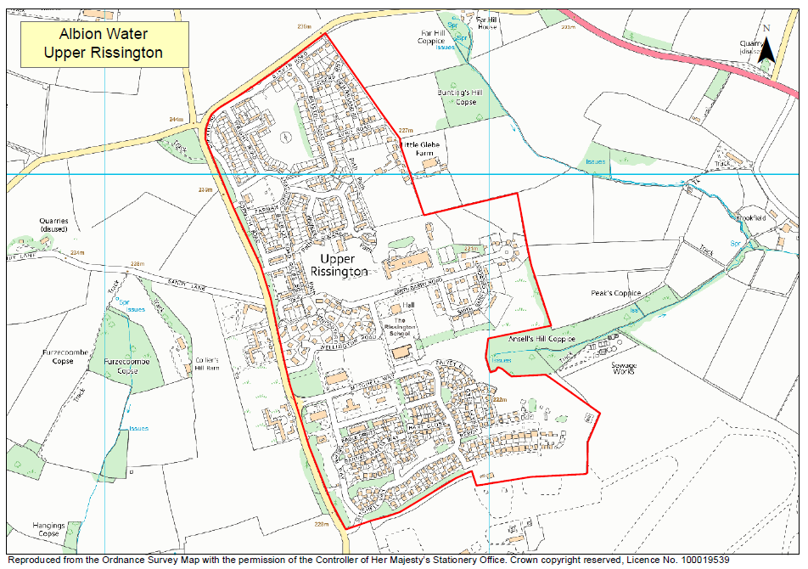
  - Five Oaks
Albion Water’s NAV license was obtained in 2016. Five Oaks is a new property development in an area of Essex that was previously unserved by Essex and Suffolk Water (water supply) and Thames Water (sewerage).
As at Upper Rissington, and following Albion Water’s preferred model, within the new development Albion Water is installing new potable and ‘non-potable’ water networks. Recycled/reclaimed water for toilet flushing and garden watering will be supplied from the ‘non-potable’ water network. When the ‘non-potable’ system is fully commissioned it will significantly reduce the volume of potable water needed to satisfy customer demand via the bulk supply connection. This is expected in 2018/19.
Once the new development area has been fully built no further properties are planned to be built within Albion Water’s area of appointment. Therefore the resource plan is based on a stable population during the majority of the planning period i.e. 2020 to 2045.
The current bulk supply agreement with Northumbrian Water (the parent company of Essex and Suffolk Water) allows for a maximum annual supply of the equivalent of 85 cubic meters per day (0.085 Ml/day) to be taken from the bulk supply point. The agreement however does require Northumbrian Water to accommodate reasonable variations from this amount. Essex and Suffolk Water have confirmed that up to at least 0.117 Ml/d would be available under this clause of the agreement. There is no termination date on the agreement and therefore it will be in force for the period of the plan.
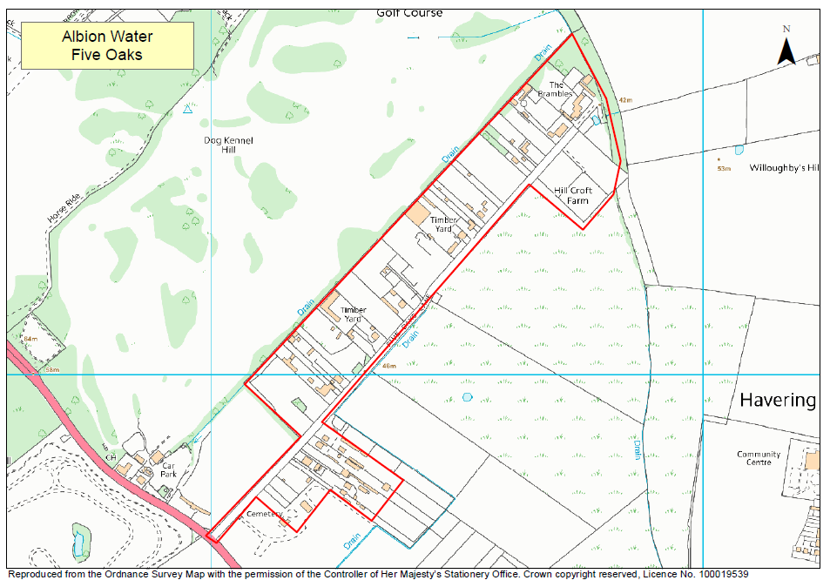

Pre – Consultation
Guidelines produced by the EA recommend that, before preparing their plans, a water company should consult with a variety of organisations. Our pre-consultation is summarised in the table below.
Consultee | Response
Environment Agency (EA) | We have been in regular contact with the Environment Agency in producing this plan. A formal consultation meeting was held on 18 September 2017. We have reflected their comments in producing this plan, in particular in our approach to 2017 Direction.
Secretary of State | No response received
Northumbrian Water | Provided information on their restrictions policy and carbon dioxide emissions
Thames Water | Provided information on their restrictions policy and carbon dioxide emissions
Consumer Council for Water (CCW) | CCW supported many of the principles outlined in the Water Resources Planning Guidelines. They encouraged us to consult with the public whilst recognising the proportionality and likely lack of proposed investments.

Water Resources

Upper Rissington
The demand for water in Upper Rissington is supplied by:
- a metered bulk supply from Thames Water
- from 2019/20 non potable demand will be met from recycled water for all the new properties on Victory Fields.
The bulk supply comes from Thames Water’s SWOX Water Resources Zone. Although the bulk supply agreement between Albion Water and Thames Water has an upper limit of 307 cubic meters per day (0.307 Ml/d) historical data shows the associated system has the capacity to supply in excess of 1000 cubic meters per day (1 Ml/d) to the bulk supply point.
As part of the Victory Fields development, a dual supply system has been installed. In total approximately 450 houses will be supplied in this way. This will allow non-potable water uses to be met with recycled water. Non-potable uses are garden watering and toilet flushing. The supplies to the houses are already separately metered and from this data it is estimated that 30% of the demand will be non-potable. Once all the houses are built the recycled water will provide a resource of approximately 0.04 Ml/d, although this capacity will be limited by the non-potable demand rather than the available treatment resource.
The non-potable treatment works is currently being designed and is expected to be fully operational during 2019/20.
The estimate of 30% saving comes from us monitoring the potable and non-potable systems separately. The data is shown on the graphs below.
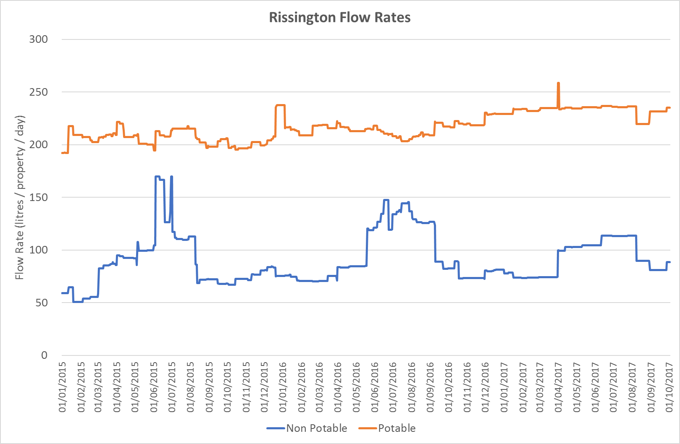

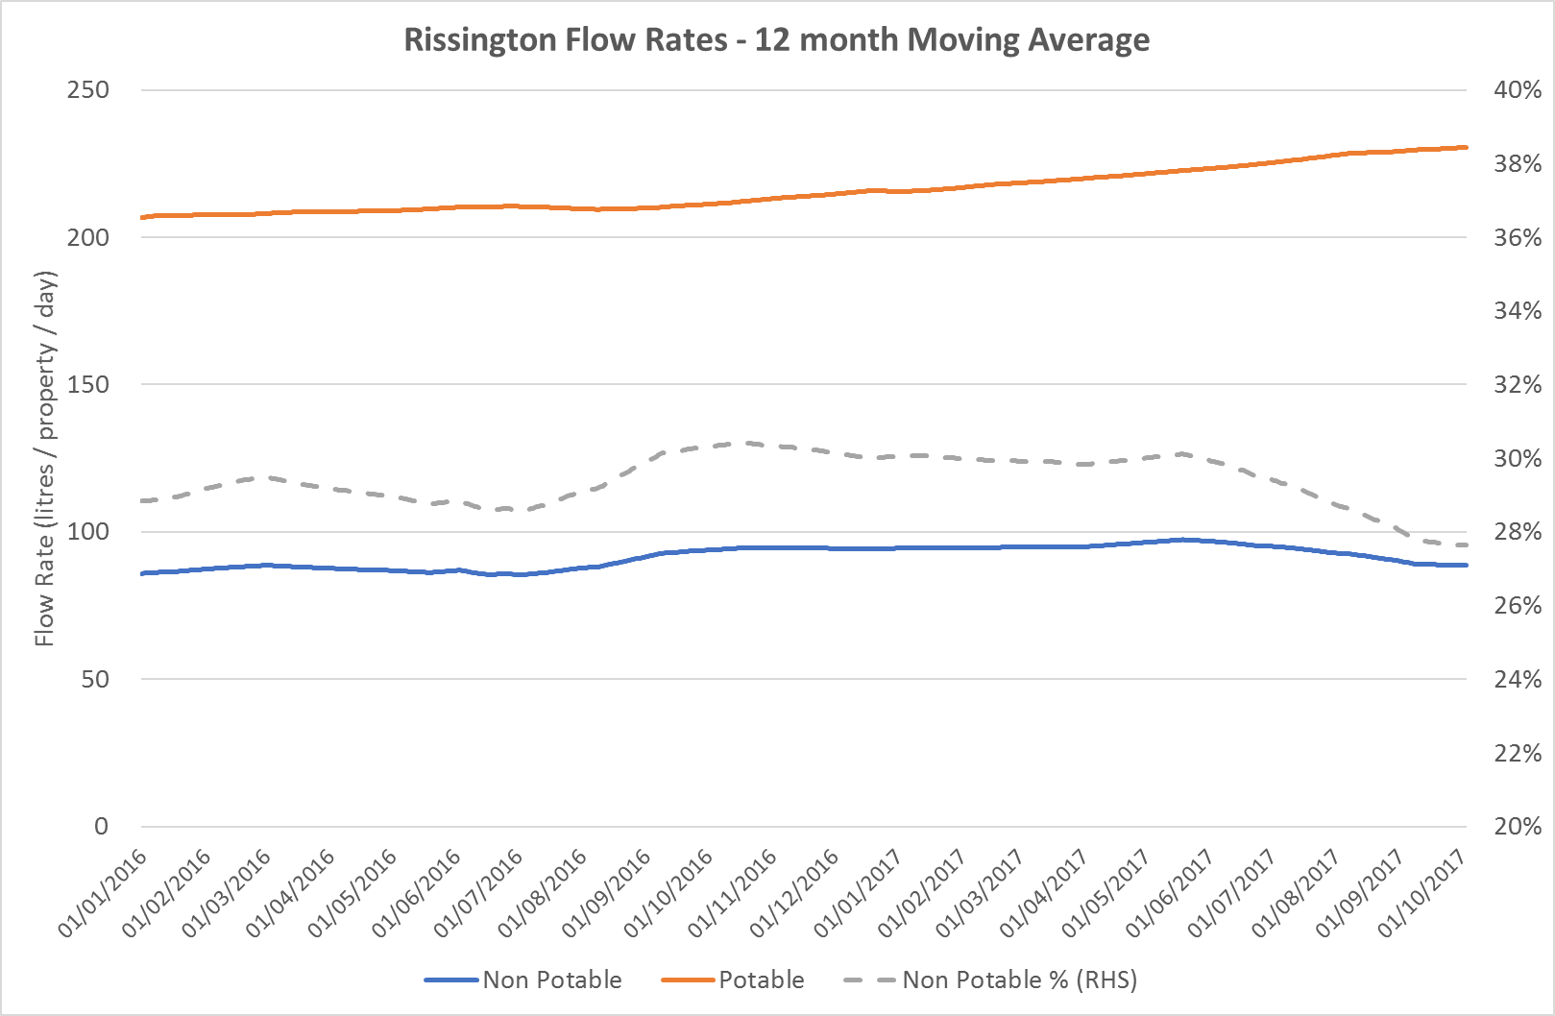

In the Water Resources Planning Tables non potable is shown as a non potable demand met with a non potable supply.

Five Oaks
The demand for water at Five Oaks is supplied by:
- a metered bulk supply from Essex and Suffolk Water
- from 2018/19 non-potable demand will be met from recycled water for all the properties on the site.
The bulk supply comes from Essex and Suffolk’s Essex Water Resources Zone. The bulk supply agreement limits the transfer to 0.085 Ml/d, although it does require Essex and Suffolk to accommodate reasonable variations. We have confirmed with Essex and Suffolk that variations up to at least 0.117 Ml/d would be available under the agreement.
As part of the development, a dual supply system is being installed. All 425 houses will be supplied in this way. This will allow non-potable water uses to be met with recycled water. Once all the houses are built the recycled water will provide a resource of approximately 0.034 Ml/d, although this capacity will be limited by the non-potable demand rather than the available resource. We assume that the non potable savings will be the same as at Upper Rissington as a percentage of total demand in a metered property.

Outage
No allowance has been made for outage in the supply demand balance. The companies providing the bulk supplies have made an outage allowance in their supply demand calculations.
There is a possibility that the water recycling plant will not be available at times. We expect outages to be rare, and mostly for planned maintenance. There is a strong incentive on the company to minimise outages as the short run marginal cost of recycled water is a lot lower than the cost of imported water. We have considered an outage at the recycling plants within our sensitivity analysis.
Should an outage occur for a period during a dry year then there is headroom within the bulk supply agreement at Rissington to accommodate this and within the agreement for Five Oaks which allows for reasonable variations above the contracted volume.
The output from the water recycling plant will be recorded on a dedicated meter. This information, linked with the cause of any outage, can be used to assess whether this approach to outage is prudent or not.

Severe droughts
The availability of water from the recycling plants will be reliable in extreme droughts, including the 1:200 year scenario, as the available resource will always exceed the demand.
The reliability of the bulk supplies is considered in the Water Demands section as any consequence of reduced reliability will be on the demand for water because of restrictions on use.

Impact of climate change
The availability of water for recycling will be not be affected by climate change as the available resource will exceed the demand for recycled water.
The bulk supply companies allow for the impact of climate change in their supply demand balance, and there is no condition in the bulk supply agreements that allows them to vary the agreed quantity as a result of climate change.

Water Demand

Historic levels of demand
The historic level of demand for Upper Rissington is shown on the graph below. Up to 1.4 Ml/d of water was regularly by Thames Water to the Upper Rissington Management Company (RMC), who were the operators of the private distribution network, prior to Albion Water’s license being varied to include the Upper Rissington area.
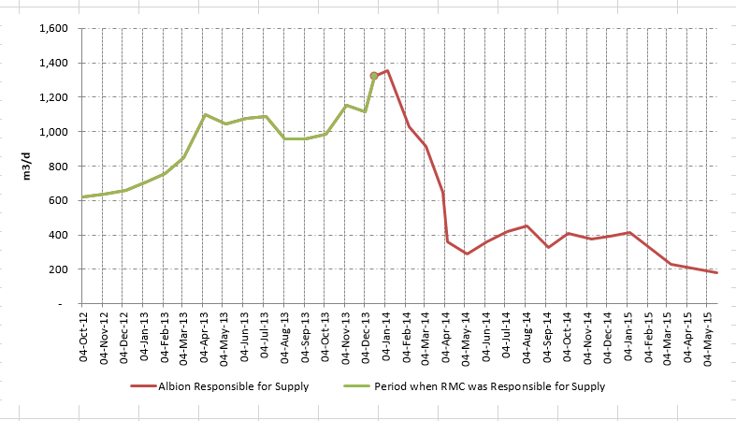
Shortly after the system came under the management of Albion Water there was a dramatic reduction in the volume of water required to service the needs of the Upper Rissington customers. This reduction was achieved by a combination of the following:
- leakage management and control
- mains rehabilitation and renewal
- network optimisation
- installation of domestic water meters with facility for automatic meter reading (AMR)

Base Year
The current split of demand has been assessed as follows, for the 2017/18 as a base year, normal weather. We have used 2017/18 as the base year as Upper Rissington has been in a period of rapid growth and this is the first year that any houses have been occupied at Five Oaks
Demand element | Upper Rissington | Five Oaks | Source / Comment
Unmeasured households
Number of properties | 266 | 0 | Billing records
Occupancy | 2.7 | N/A | Wessex Water
Population | 718 | N/A | Calculation
Water supplied | 0.111 Ml/d | N/A | Based on non-revenue meters in distribution
PCC | 155 l/h/d | N/A | Calculation
Measured households
Number of properties | 376 | 50 | Billing data
Occupancy | 2.34 | 2.05 | Upper Rissington – from WW, average measured occupancy  Five Oaks – from NAV models, houses are generally smaller at Five Oaks
Population | 880 | 103 | Calculation
Water supplied | 0.104 Ml/d | 0.013 Ml/d | Upper Rissington – billing data  Five Oaks - Calculation
PCC | 118 l/h/d | 125 l/h/d | Upper Rissington - Calculation  Five Oaks – from NAV model
Non-households
Number of properties | 18 | 0
Population | 30 | 0 | Of the 18 properties only 11 are occupied
Water supplied | 0.002 Ml/d | 0 Ml/d | Billing records
Other
Leakage | 0.01 Ml/d | 0.001 Ml/d | Minimum night flows and financial models used in NAV applications.
Water taken unbilled | 0.033 Ml/d | 0 Ml/d | Estimate - At Upper Rissington we are working with the developers to reduce the water taken unbilled.  At Five Oaks the building water supply is via a separate connection from Essex & Suffolk.

Leakage
For Upper Rissington we have assessed leakage via the minimum night flow method. The graphs below show the minimum daily flow from the two bulk meters that supply the NAV area. Minimum night flows have been picked from the underlying data based on 2 hour minimums, 1 hour minimums, 30 minute minimums and 15 minute minimums. For both meters the variation between the 2 hour minimum and the 15 minute minimum is small.
Legitimate night use has been assessed as 2.0 l/prop/d for an unmetered property and 1.7 l/prop/d for a metered property, using typical figures provided by Wessex Water.
The table below show the resulting calculation. This shows leakage to be low and close to zero, particularly for the metered network. This seems unrealistically low. Therefore in the WRMP tables we have used the 4% assumption used in the financial models presented to Ofwat at the time of the NAV applications. Once the development on the site is complete steady state conditions should prevail and we can make a revised assessment of leakage.
This level of leakage is very low, and much lower than when Albion Water took over the site.
For Five Oaks we have also used 4% as there is insufficient site data to assess leakage.
 | Units | Victory Fields | The Camp | Total
Minimum Night Flow | l/s | 0.185 | 0.22 | 0.405
Properties | Number | 376 | 266 | 642
Legitimate Night Use | l/prop/hr | 1.7 | 2
 | l/s | 0.178 | 0.148 | 0.325
Leakage | l/s | 0.007 | 0.0072 | 0.080

Going forward we will keep leakage at these rates or below. This will be done by continuous scrutiny of the night lines and fixing any leaks that are detected either via the night lines, Albion Water staff or reported by customers.
We have no plans to use Consistency of Reporting Performance Measures (UKWIR 2017) methodology as we only manage two very small DMAs and leakage is at very low levels indeed.
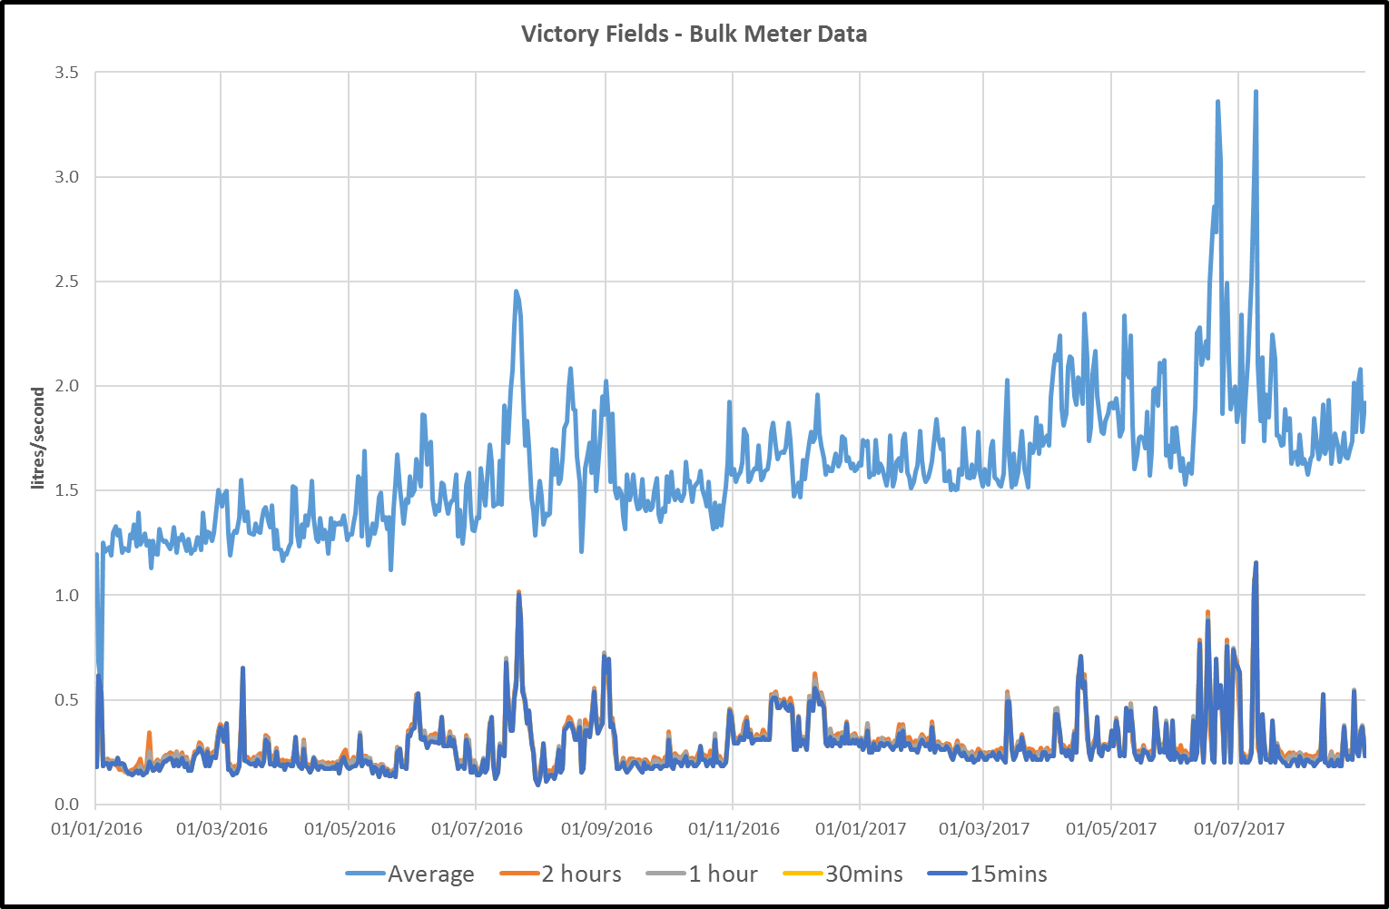

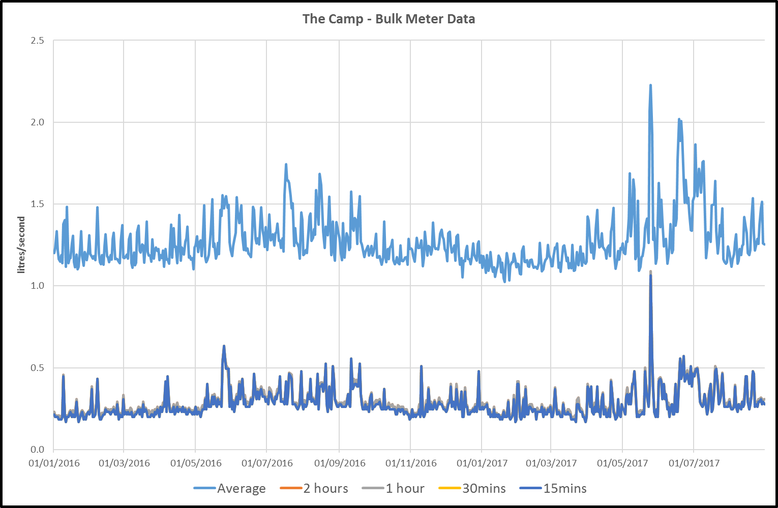

Demand forecasting
For Upper Rissington, the site is assumed to be fully built out by 2019/20. Thereafter property numbers are assumed to be static.
For Five Oaks, the construction and occupation period will run from 2017 with full occupation assumed in 2021/22. Thereafter property numbers are assumed to be static.
These assumptions are based on the latest discussions with the developers.
  - Population forecasts
Population will follow the property build out process. Any subsequent change in population will be very small compared to the change as a result of the build out and therefore it has not been explicitly modelled.
  - Metering
All new properties at both sites are metered. Therefore all the properties at Five Oaks are metered. When Albion Water took over the supply to the Camp area at Upper Rissington all properties were offered the chance to switch to a meter. Only one took it up and they subsequently switched back. Additionally, the nature of the original MoD connections to properties makes it very difficult to meter individual properties. Albion Water installed meters on groups of unmetered properties, such that most unmetered properties are metered upstream.
On average our meters cost £300 to install, as they include loggers. The cost of each meter to operate is estimated at £10 per year.
For the avoidance of doubt we are forecasting that the following meters will be installed. Where appropriate we comment on the cost effectiveness of different metering strategies.
Type of metering | Numbers | Comment
Optant metering | None | Five Oaks - fully metered.
 | Insignificant | Upper Rissington - based on last few years, there is no price incentive for households to switch (tariffs are capped at Thames Water charges). Cost effectiveness is not applicable as it is a customer decision supported by information we provide.
Change of occupier | None | Five Oaks is fully metered.
 | Insignificant | Upper Rissington - where it was practical all unmetered properties at Upper Rissington were metered when we took on responsibility for the supply – however they continued to pay on an assessed charge unless they chose otherwise. However, when there is a new occupier we switch the customer to a paying by meter. This approach is cost effective as the meters are already installed – zero cost for a benefit in reducing water usage and ensuring our income balances our costs.
New build metering | See WRMP tables | All new properties. Cost effectiveness is not applicable as it is a legal requirement.
Compulsory metering | None | Five Oaks is fully metered.
 | None | Not permitted as Upper Rissington is not water stressed. In WRMP cost effectiveness terms as there is no deficit the cost would be £300 per meter for zero benefit.
Selective metering | None | Five Oaks is fully metered.
 | None | Not permitted as Upper Rissington is not water stressed. In WRMP cost effectiveness terms, as there is no deficit, the cost would be £300 per meter for zero benefit.

  - Changes in PCC
The biggest change in PCC is the introduction of non-potable water in 2018/19 at Five Oaks and 2019/20 for the 450 Victory Fields properties at Upper Rissington. To make clear the impact that this has on potable PCC in the tables we have shown this as a non-potable supply meeting a non-potable demand.
  - Changes in non-household demand
Non household demand at Upper Rissington is expected to grow over the next couple of years as properties are let. After that we have forecast stable non household demand.
There is no non-household demand at Five Oaks.
  - Changes in leakage
Leakage is assumed to be constant at 4% of other water demand for both sites. Leakage does rise slightly across the planning period as a result of the build out of the sites and their associated distribution networks, but does not increase as a percentage of distribution input. This is particularly the case for Five Oaks which had not started in the base year. Thie 4% figure will be reviewed as more data becomes available, but currently the night flow data from Upper Rissington indicates that leakage is very close to zero.
Going forward we will keep leakage at these rates or below. This will be done by continuous scrutiny of the night lines and fixing any leaks that are detected either via the night lines, Albion Water staff or reported by customers.
We have no plans to use Consistency of Reporting Performance Measures (UKWIR 2017) methodology as we only manage two very small DMAs and leakage is at very low levels indeed.

  - Dry year uplift
Measured household demand is assumed to be 3.4% higher in a dry year than a normal year, and household unmeasured demand will be 7.2% higher. These uplift factors have been provided by Wessex Water. No increase in non-household demand is assumed in a dry year.
  - Impact of climate change
We have made no allowance for the impact of climate change. Approaches across the industry are to make either a very small or zero allowance. Given that we supply mostly new houses and flats with small or no gardens we think the risk of a significant increase in demand on our system from climate change is negligible.

Headroom
Given that both areas are small ring-fenced developments there are limited uncertainties in our plan. The main ones will be:
- Population forecasts
- Changes to PCC
- Number of void properties at any one time
To assess a notional worst case we have considered the impact of demand being 10% higher than in our central forecast. Headroom has therefore been calculated as 10% of demand.

Supply demand balance
The supply demand balance is illustrated in the graphs below. This shows the demand for water being met by a combination of bulk imports and recycled water. The graphs show the contracted volume agreed with the bulk suppliers.
Allowing for headroom no supply demand deficit is forecast over the period of the plan (comparison of yellow lines with grey lines).
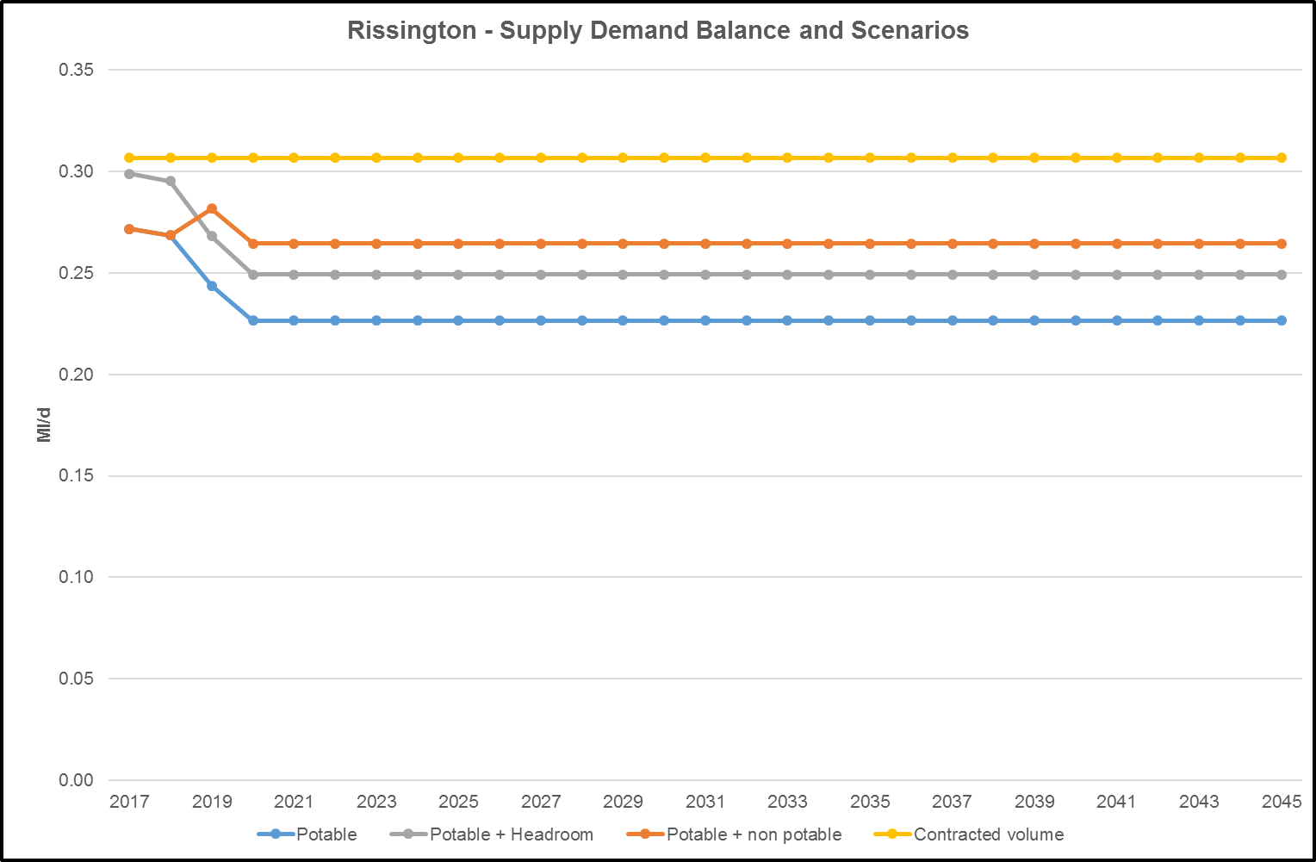

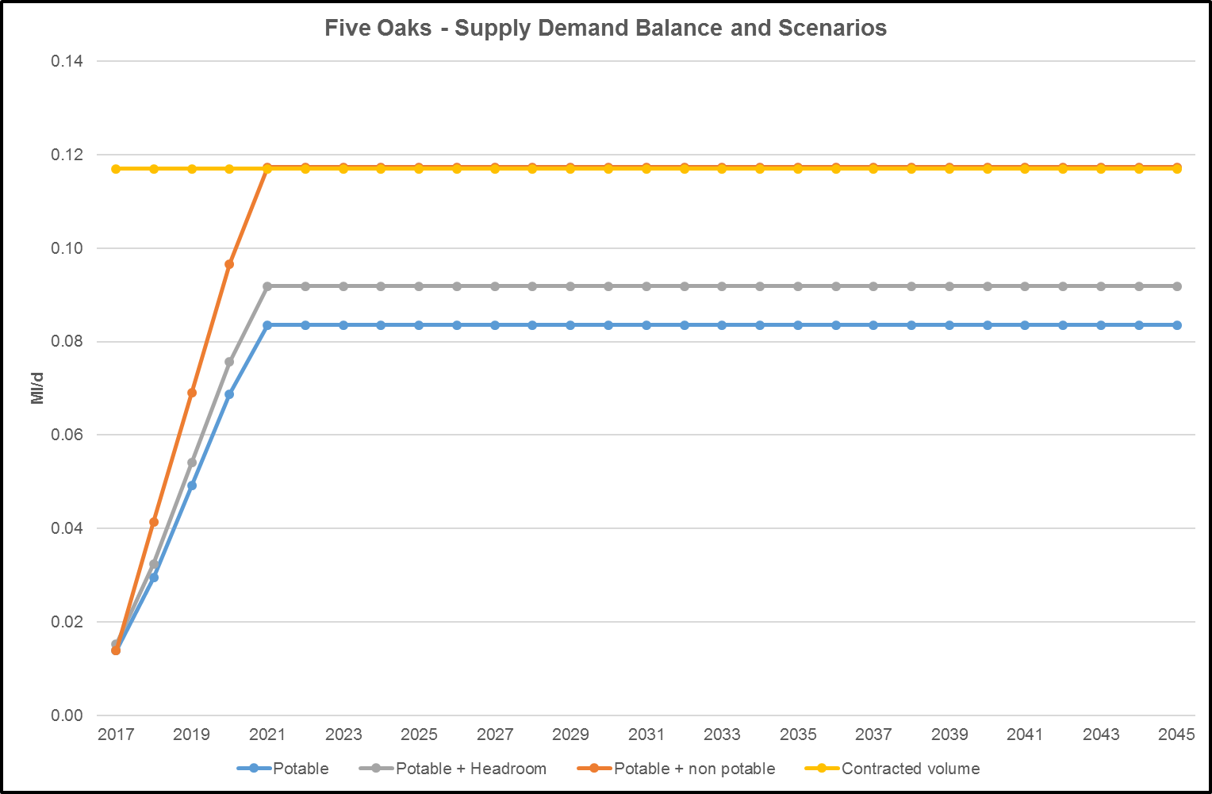

Sensitivity
We have also assessed the impact on the import requirements if the non-potable supply were unavailable.
This scenario is shown on the graphs above (orange line). For both sites potable water demand is within the contracted bulk supply agreements.

Drought reliability and drought actions
The contracts with Essex and Suffolk (Five Oaks) and Thames (Upper Rissington) both require Albion Water to at least match the restrictions they impose on their customers in the area in the event of a drought. We have asked both companies to confirm their policies on restrictions. These are set out below.

Upper Rissington
Thames Water have advised as follows:
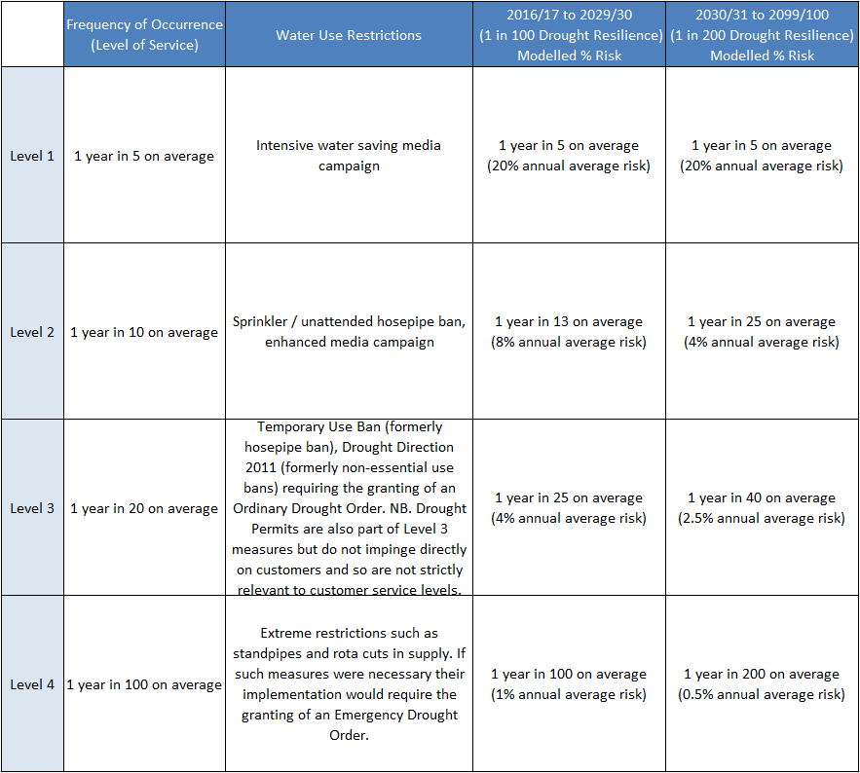

Five Oaks
Essex and Suffolk have confirmed the following.
WIA Section 76 - Temporary hosepipe bans: 1:20 or 5% risk – will stay the same over the 25 year planning horizon.
WRA Section 74(2)(b) - Ordinary drought order: 1:50 or 2% risk – will stay the same over the 25 year planning horizon.
WRA Section 75 - Emergency drought order: 1:250 or 0.4% risk – will stay the same over the 25 year planning horizon.
Under a 1 in 200 year drought scenario, they expect to impose up to Level 3 restrictions. These are defined in their drought plan as follows:
These are far rarer (1 in 50 years) but when they are put in place it will always be after a Temporary Use Ban has already been in implemented. The Drought Order Bans basically ban what has been applicable to the domestic customer under the Temporary Use Ban, to non-domestic or commercial customers. These bans have economic consequences for businesses and have to be used as sparingly as possible. Our intention would be to apply for powers to ban all of the activities open to us, but only apply each restriction when necessary and beneficial in terms of water savings and economic impact.
The deployable output for their Essex Water Resource Zone is calculated using their Essex Aquator model. This uses naturalised flows from 1915 to 2014 and includes their design drought year of 1933/34. They have reviewed the frequency of the restrictions that would have been imposed and have concluded that they would be less frequent than that of their stated levels of service.

Green Water
At both Upper Rissington and Five Oaks Albion Water will shortly have operational green water recycling plant providing non-potable water, including for garden watering. Given that a key purpose of the recycling is provide additional resilience during times of dry weather and drought we would only impose a restriction on its use in the 1:200 drought scenario or worse. In terms of the severity of a particular drought we would be guided by the bulk supply water company and the Environment Agency.

Other matters referred to in Guidance and Directions

Greenhouse gas emissions accounting
At full site build out we predict greenhouse gas emissions will be as follows:
 | Upper Rissington | Five Oaks
Annual volume – potable | 83,220 m3 | 30,600 m3
CO2 emissions per cubic metre | 0.141kg/m3 | 0.284kg/m3
CO2 emissions – potable | 11,700 kg/year | 8,700 kg/year
Annual volume – non-potable | 13,870 m3 | 12,410 m3
CO2 emissions per cubic metre | 0.1kg/m3
CO2 emissions – non-potable | 1,400 kg/year | 1,200 kg/year
CO2 emissions – total, per year | 13,100 kg/year | 9,900 kg/year

The figures for emissions per cubic metre for potable water have been obtained from the companies providing bulk supplies to us. The non-potable figures have been obtained from EA Science Report – SC070010 (2008) – Figure 6.1 and Table 6.1. For effluent reuse this report gives a range of emissions from 0.1 kg/m3 up to 0.500kg/m3. We have used the lower end of the range because:
- Most of the effluent treatment is happening anyway for the counterfactual of direct discharge to the environment
- Our treatment effluent treatment plants are on site and therefore pumping costs will be at the lower end of the range.

Resilience
The bulk supply agreements have clauses in them which relate to resilience, in particular the actions to be taken by both parties should there be a problem in maintaining the bulk supply. These include the provision of an alternative back up connection or an alternative supply of water by bowser, temporary mains, bottled water or otherwise.
The key non drought risk that may affect Albion Water is an interruption to the bulk supply. Such an event occurred in July 2018. This event reinforced the importance of communication between the bulk supply provider and the NAV to ensure that the we can communicate effectively with our customers and take appropriate action in terms of providing alternative supplies of water during the incident.
A freeze-thaw induced leakage breakout is also a risk. Our network is entirely new or recently refurbished and therefore the risk of a leak on our network is low. During the “Best from the East” period in late February / early March 2018 demand remained consistent with the previous and subsequent periods. However over a three day period there was a jump in demand which must have related to an internal customer leak as we did not attend to, or repair, any leaks. No contact was received from the customer, or customers, who experienced these internal leaks.
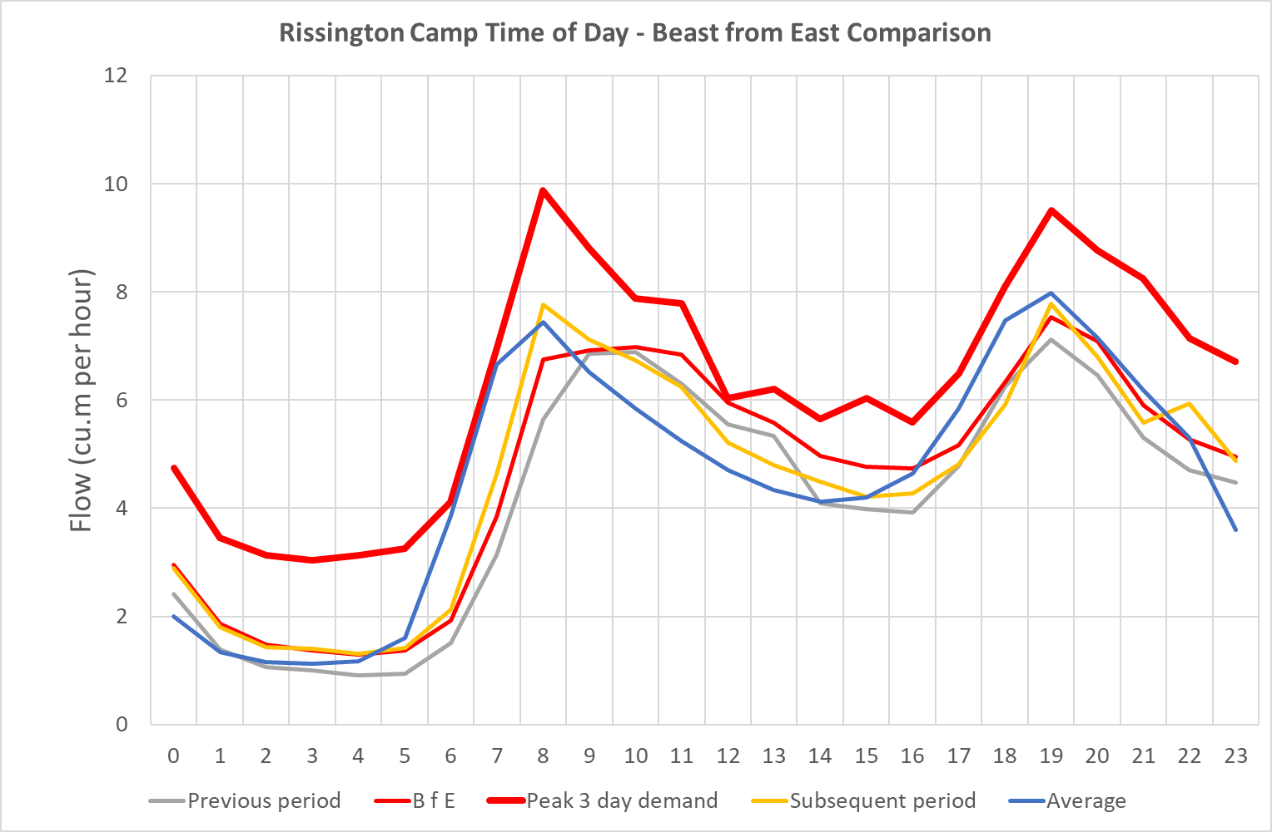

Commercial confidentiality
There is no commercially confidential material in this document.

Board assurance
This draft Water Resources Management Plan was considered by the Board of Albion Water Limited on two occasions.
On the 18 September 2017, the Board agreed the assumptions from which the plan is build up.
On the 20 November 2017, the Board reviewed the resulting Supply Demand balance. They provided assurance that the plan would meet our customers demand for water over the next 25 years, but requested that clarity is obtained from Essex and Suffolk Water on the detailed terms of the bulk supply agreement relating to the maximum quantity.

Tables
2.1BL – This line has been used to show the water supplied from the water recycling (Green Water) plant.
3.1BL – This line has been used to show the contracted volume of the import. For Five Oaks this does not include any additional amount allowed for as a “reasonable variation” from this rate.
10 BL – Outage – Outage is generally a matter for the bulk supply company to manage, although in the plan we have considered the impact of the scenario of the water recycling plant being unavailable.

14 & 15 BL – Headroom – Uncertainty in demand forecasting has been modelled as an allowance of 10% of demand.
We have only split household demand into potable (supplied via the bulk supply) and non potable (supplied from the green water treatment plant). We have provided evidence for the proportions.
Worksheets 5 to 9 have not been completed as there are no deficits predicted.
Worksheet 10 – our approach to droughts is outlined in the section of this plan on Drought Reliability and Drought Actions. Demand side reductions will follow those imposed by the incumbent, and will result in a reduction in the actual bulk supply volume taken. The demand side “benefit” will therefore accrue to the incumbent not to Albion Water. Should Albion Water impose restrictions on the use of non-potable water this will not affect the resource position as the impact will be more treated effluent in the river – which we assume will be the primary driver for any such restriction being imposed.

Table changes from Draft Plan
The following input lines have been changed from the draft plan.
Upper Rissington – Table 2.BL Supply – Row 5.1BL – Inputs updated to reflect output of non-potable plant.
Upper Rissington – Table 3.BL Demand – Row 39BL – Distribution lossess – Input updated to correct incorrect figures. Previous figures related to Five Oaks area.

